**1.** **write a java program that create class hierarchy for emp of a company the base class should be employee with subclasses manager developer andprogrammer each subclass should have properties such as name address salary and job title with implement method for calculating code and generating performance of a report**

**Program:**

**class Employee {**

**protected String name;**

**protected String address;**

**protected double salary;**

**protected String jobTitle;**

**public Employee(String name, String address, double salary, String jobTitle) {**

**this.name = name;**

**this.address = address;**

**this.salary = salary;**

**this.jobTitle = jobTitle;**

**}**

**public double calculateBonus() {**

**return salary * 0.1;**

**}**

**public void generatePerformanceReport() {**

**System.out.println("Employee Name: " + name);**

**System.out.println("Job Title: " + jobTitle);**

**System.out.println("Salary: " + salary);**

**}**

**}**

**class Manager extends Employee {**

**private String department;**

**public Manager(String name, String address, double salary, String jobTitle, String department) {**

**super(name, address, salary, jobTitle);**

**this.department = department;**

**}**

**@Override**

**public double calculateBonus() {**

**return super.calculateBonus() * 1.5;**

**}**

**@Override**

**public void generatePerformanceReport() {**

**super.generatePerformanceReport();**

**System.out.println("Department: " + department);**

**}**

**}**

**class Developer extends Employee {**

**private String programmingLanguage;**

**public Developer(String name, String address, double salary, String jobTitle, String programmingLanguage) {**

**super(name, address, salary, jobTitle);**

**this.programmingLanguage = programmingLanguage;**

**}**

**@Override**

**public void generatePerformanceReport() {**

**super.generatePerformanceReport();**

**System.out.println("Programming Language: " + programmingLanguage);**

**}**

**}**

**class Programmer extends Developer {**

**public Programmer(String name, String address, double salary, String jobTitle, String programmingLanguage) {**

**super(name, address, salary, jobTitle, programmingLanguage);**

**}**

**@Override**

**public double calculateBonus() {**

**return super.calculateBonus() * 1.2;**

**}**

**}**

**public class Main {**

**public static void main(String[] args) {**

**Manager manager = new Manager("John Doe", "123 Main St", 100000, "Manager", "IT");**

**manager.generatePerformanceReport();**

**System.out.println("Bonus: " + manager.calculateBonus());**

**Developer developer = new Developer("Jane Smith", "456 Elm St", 80000, "Developer", "Java");**

**developer.generatePerformanceReport();**

**System.out.println("Bonus: " + developer.calculateBonus());**

**Programmer programmer = new Programmer("Bob Johnson", "789 Oak St", 70000, "Programmer", "Python");**

**programmer.generatePerformanceReport();**

**System.out.println("Bonus: " + programmer.calculateBonus());**

**}**

**}**

**Output:**

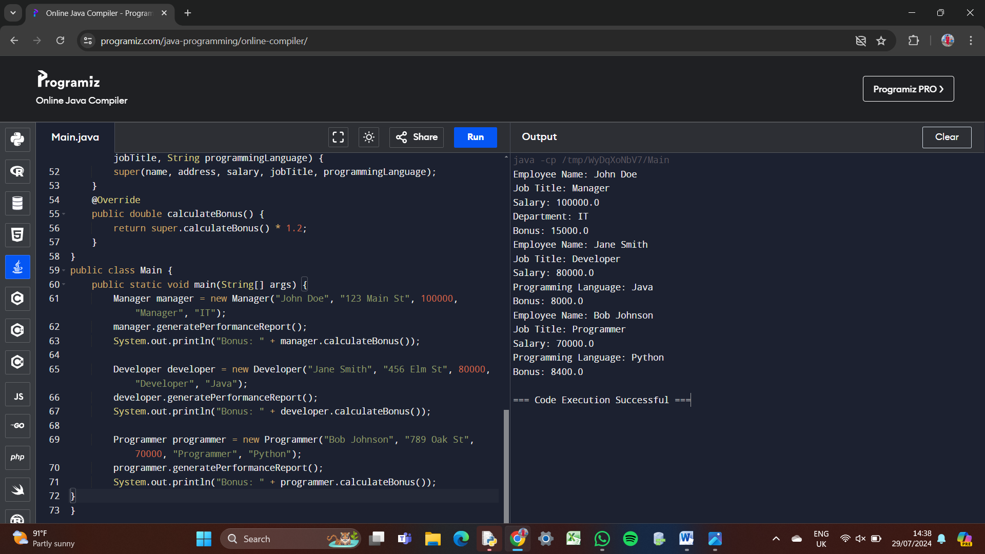

**2.write a java program to create method that take on intergers as parameter throws exception if the number is odd.**

**Program:**

**public class Main {**

**public static void checkEven(int number) throws Exception {**

**if (number % 2 != 0) {**

**throw new Exception("The number is odd: " + number);**

**} else {**

**System.out.println("The number is even: " + number);**

**}**

**}**

**public static void main(String[] args) {**

**try {**

**checkEven(3); // Change this number to test with different values**

**} catch (Exception e) {**

**System.err.println(e.getMessage());**

**}**

**}**

**}**

**Output:**

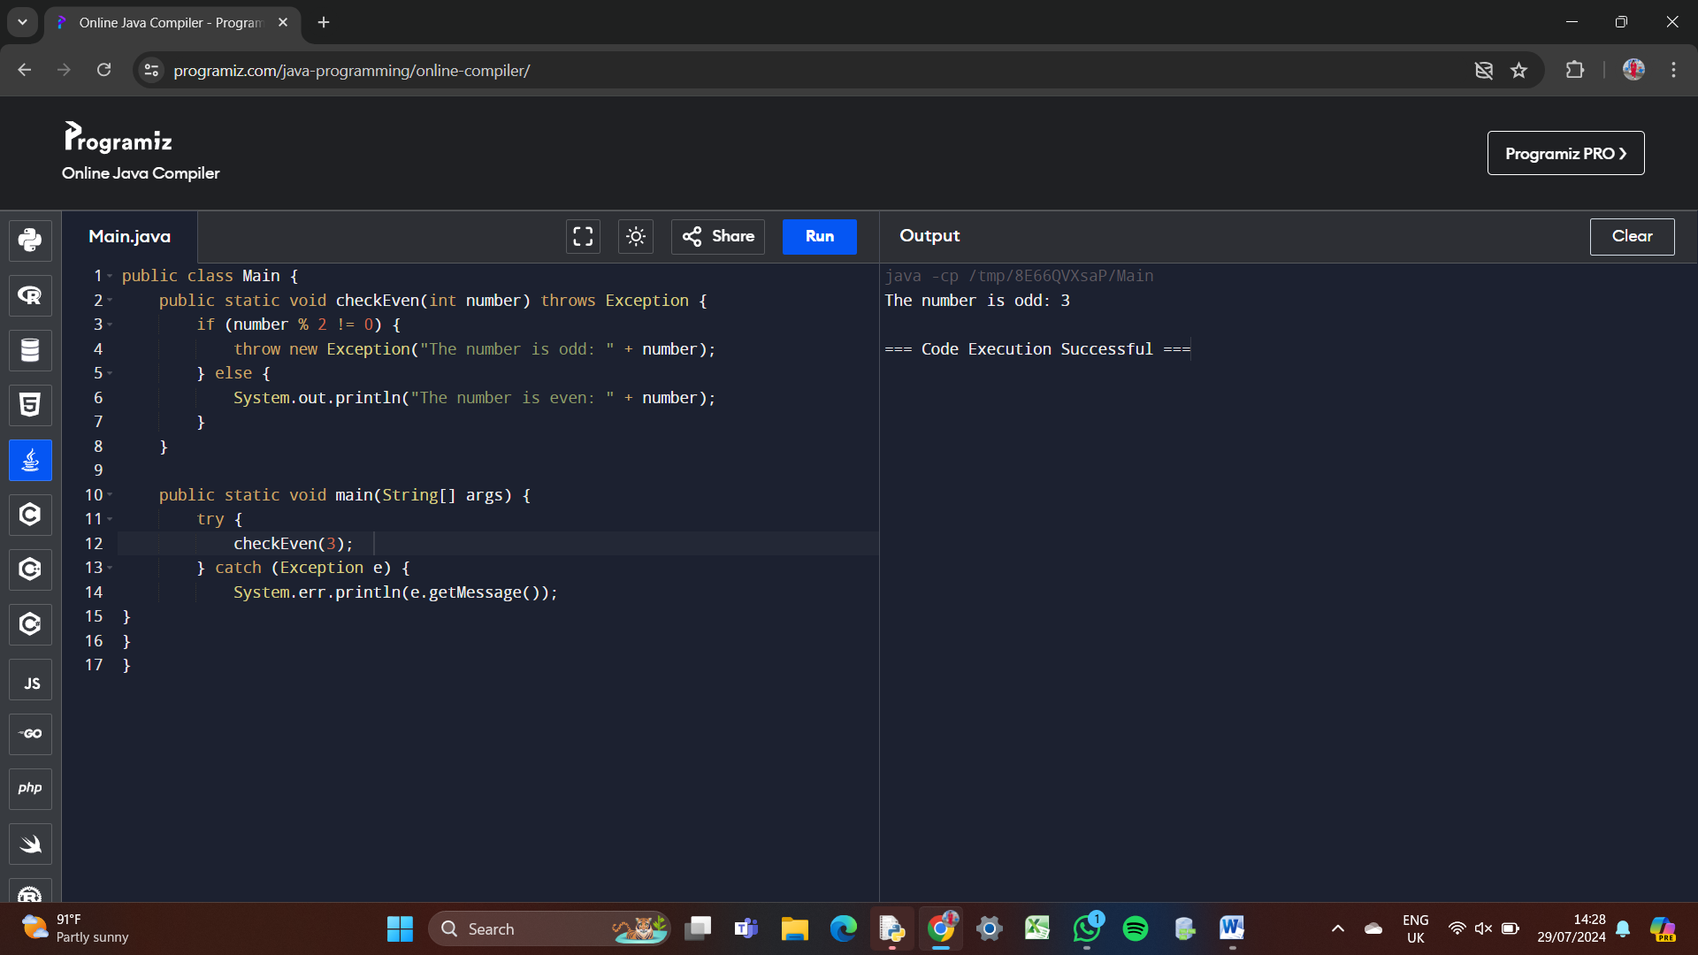

**3.write a java create method that string as input throws an exception does not contain vowel.**

**Program:**

**public class VowelChecker {**

**public static void checkVowels(String input) throws VowelException {**

**String vowels = "aeiouAEIOU";**

**for (char c : input.toCharArray()) {**

**if (vowels.indexOf(c)!= -1) {**

**throw new VowelException("The string contains vowels");**

**}**

**}**

**System.out.println("The string does not contain vowels: " + input);**

**}**

**public static class VowelException extends Exception {**

**public VowelException(String message) {**

**super(message);**

**}**

**}**

**public static void main(String[] args) {**

**try {**

**checkVowels("bcd");**

**checkVowels("hello");**

**} catch (VowelException e) {**

**System.out.println(e.getMessage());**

**}**

**}**

**}**

**Output:**

